.: Preliminary Conference Program :.

Monday, 20 June 2011 Katowice-Tarnowskie Góry

8.00
Reception (Katowice, Krasińskiego street 8)

10.00
Opening Session

13.00
Travel to Tarnowskie Góry

14.00
Lunch in the hotel

15.00
Tour of the Historic Silver Mine

18.00
Presentations in sections (company presentations)

20.00
Friendly meeting

Tuesday, 21 June 2011 Tarnowskie Góry

8.00
Breakfast

9.00
Poster session

11.45
Tour of the General Motors Manufacturing Poland Sp. z o.o.

14.30
Lunch

16.00
Presentations in sections
20.00
Official Dinner

Wednesday, 22 June 2011 Tarnowskie Góry

8.00
Breakfast

8.30
Tour of the Castle of Wrochem, Presentations in sections

14.00
Lunch

15.00
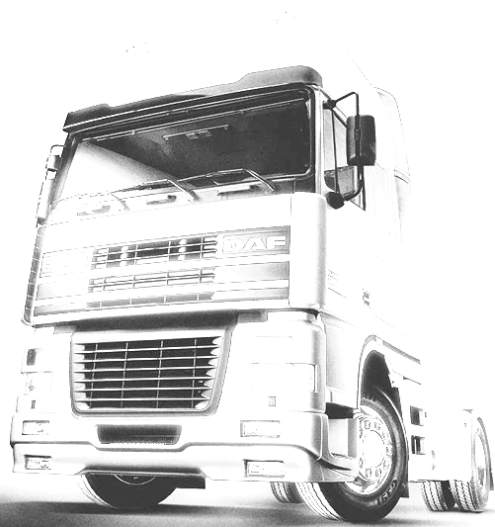
Conference close

.: Organizing Committee :.
Chairman:
Ph.D. Henryk Bakowski
henryk.bakowski@polsl.pl
Co-chairman:
Ph.D. Damian Gaska
M.Sc. Tomasz Haniszewski
M.Sc. Marcin Bugdol
M.Sc. Artur Ryguła

.: Conference Organizing Committee Address :.

III International Scientific Conference
TRANSPORT PROBLEMS
Faculty of Transport, Silesian University of Technology
Krasińskiego 8 Street,
40-019 Katowice
Poland

tel. +48 32 603 42 92
fax. +48 32 603 42 92
e-mail: tp@polsl.pl

Media Patronage:









.



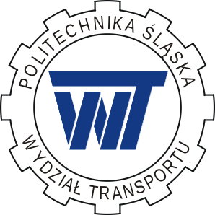

III International
Scientific Conference

TRANSPORT PROBLEMS

Silesian University of Technology
Faculty of Transport

Katowice – Tarnowskie Góry, 20 – 22 June 2011

Announcement No. 3

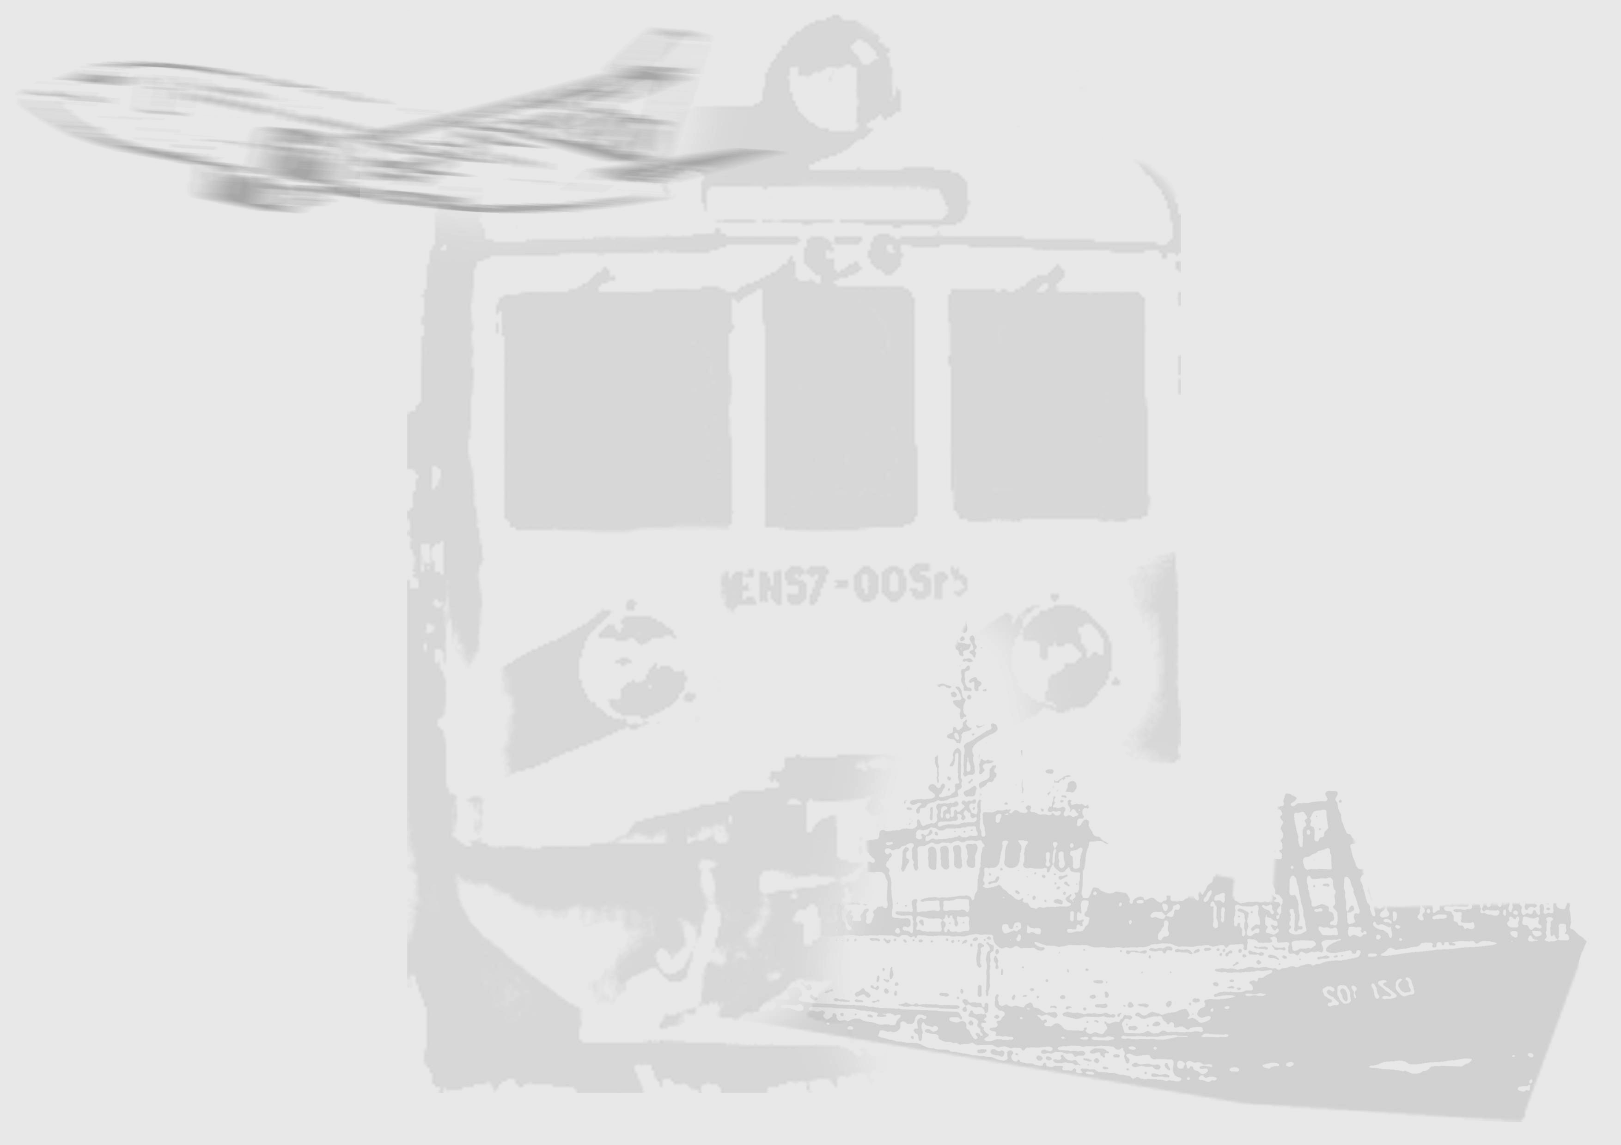
.: International Science Committee :.

Chairman:
Prof. Aleksander Sładkowski (Poland)

Co-chairman:
Prof. Bogusław Łazarz (Poland)
Prof. Henryk Madej (Poland)
Prof. Krystian Wilk (Poland)

Prof. Anvar Adylhodzaev (Uzbekistan)
Prof. Rasim Alguliyev (Azerbaijan)
Prof. Gerd-Axel Arens (Germany)
Prof. Peteris Balckars (Latvia)
Prof. Żilwinas Bazaras (Lithuania)
Prof. Klaus Becker (Germany)
Prof. Roman Bogacz (Poland)
Prof. Tatiana Čorejová (Slovakia)
Prof. Irina Englezi (Ukraine)
Prof. Radim Farana (Czech Republic)
Prof. Aleksander Golubenko (Ukraina)
Prof. Ajay Kapoor (Australia)
Dr Stanisław Krawiec (Poland)
Prof. Leonas Povilas Lingaitis (Lithuania)
Prof. Mirosław Luft (Poland)
Prof. Gabriele Malavasi (Italy)
Dr Marija Malenkovska Todorova (Macedonia)
Dr Marin Marinov (United Kingdom)
Prof. Jerzy Mikulski (Poland)
Prof. Leszek Mindur (Poland)
Prof. Andrzej Mitas (Poland)
Prof. Liudvikas Narkaitis (Lithuania)
Dr Alfonso Orro (Spain)
Prof. Stanislav Pavlin (Croatia)
Prof. Paweł Piec (Poland)
Prof. Dmitrij Pogorelov (Russia)
Dr Mihaela Popa (Romania)
Prof. Valery Sapoznikov (Russia)
Prof. Hayrettin Kemal Sezen (Turkey)
Prof. Abilio Manuel Pereira da Silva (Portugalia)
Prof. Janusz Szpytko (Poland)
Dr Nelly Stoytcheva (Bulgaria)
Prof. George Tumanishvili (Georgia)
Prof. Robert Tomanek (Poland)
Prof. Antal Veha (Hungary)
Prof. Wojciech Wawrzyński (Poland)
Prof. Tomasz Węgrzyn (Poland)

.: Conference topics :.

Conference topics include the following areas:

- road transport, rail transport, air transport, sea transport and inland,
- municipal and bicycle transport,
- industrial transport,
- load preparation, organization and co-ordination cargo handling,
- co-ordination methods and transport logistics center, integrated transport systems,
- intermodal, multimodal and
compound transport,
- computer systems aided design of transport facilities,
- means of transport production,
- technical diagnostic means of transport,
- active and passive vehicles safety,
- transport systems safety,
- traffic forecasting and region requirements, statistical research,
- influence of the law regulations on the road traffic safety,
- transport management in urban area,
- modelling and simulation transport systems,
road traffic controllers,
- automation in transport,
- ecological problems in transport,
- education and instruction in transport.

.: Important dates :.

Registration and submission of summarizes 2 April 2011

Notification of paper reception 15 May 2011

Full paper submission 15 May 2011

Payment of the conference fee 31 May 2011

All papers will be published in the conference materials; the selected ones after positive revision will be published in the International Scientific Journal „Transport Problems”
(ISSN 1896 – 0596) or in another journal which patronizes the conference. Information for authors is located on the website:
http://www.transportproblems.polsl.pl/en/Info/

.: Conference fee :.

Participation in the conference: 400 € (1600 zł)

Payment for an accompanying person 350 € (1400 zł)

(Students of master’s and PhD studies can receive a
discount of 50 € = 200 zł)

Payment includes: full board, accommodation at a hotel, integration evening, drinks, publication costs, participation in the conference, conference materials, coach travel, organisation costs.
Conference Registration will be made according to the instructions available on the website: www.konferencje.polsl.pl/tp

Please transfer money to the account at Bank Śląski S.A. O / Katowice IBAN PL 30 1050 1214 1000 0007 0000 8022, SWIFT: INGB PL PW with postscript „Conference TP’11 – name and surname of participant”
During the conference and in the conference materials the possibility of company products and activity presentations is provided. Interested persons are asked to contact with the organizing committee.

